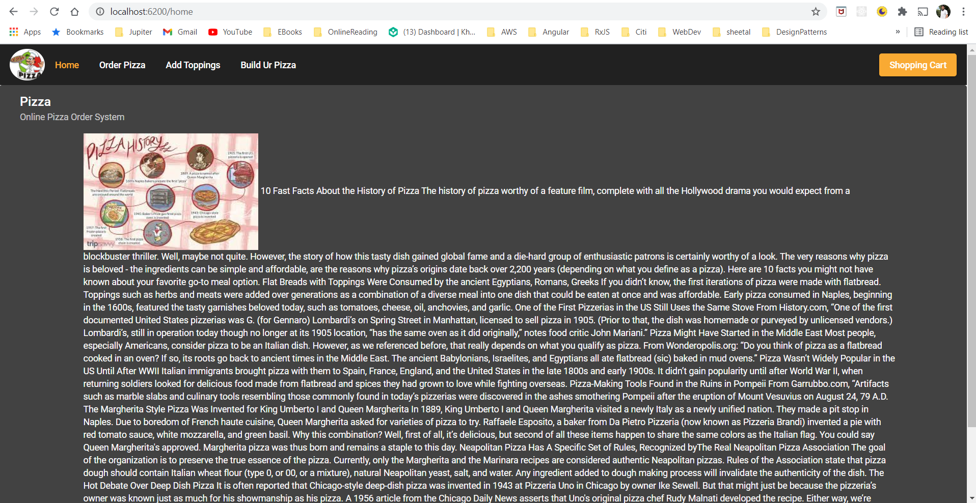

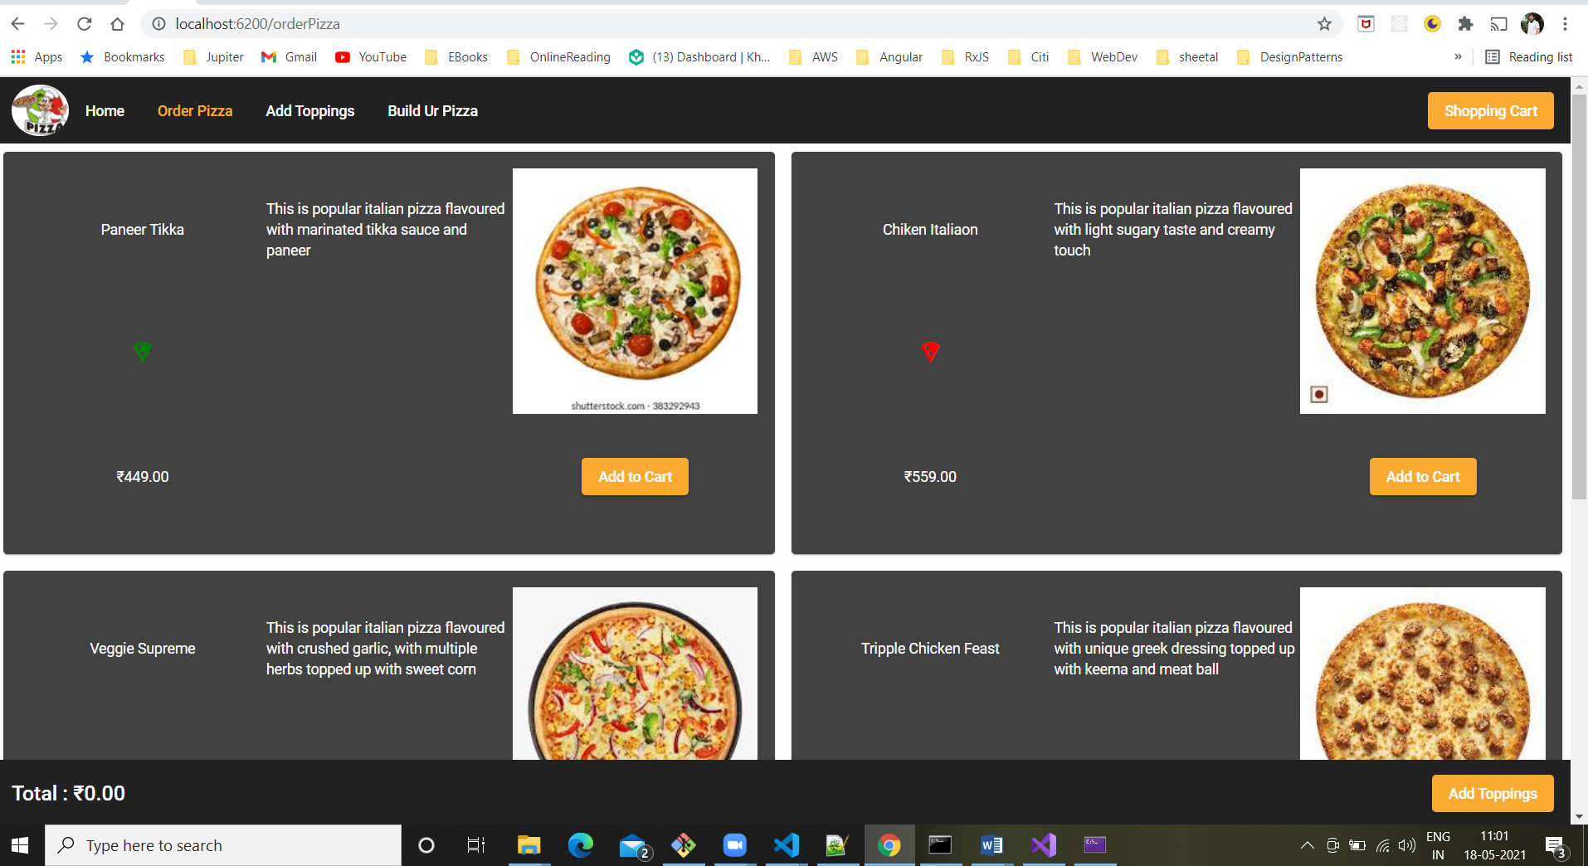

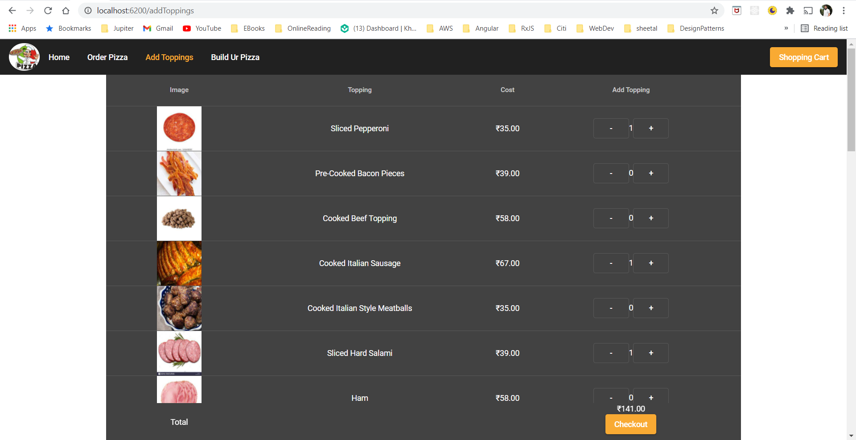

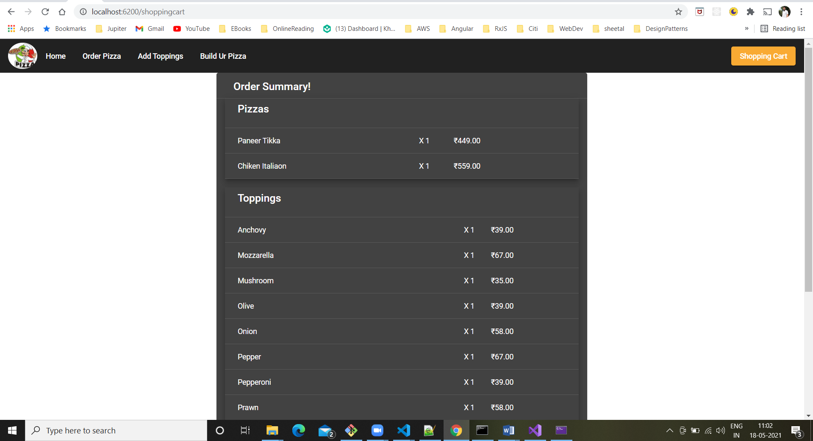

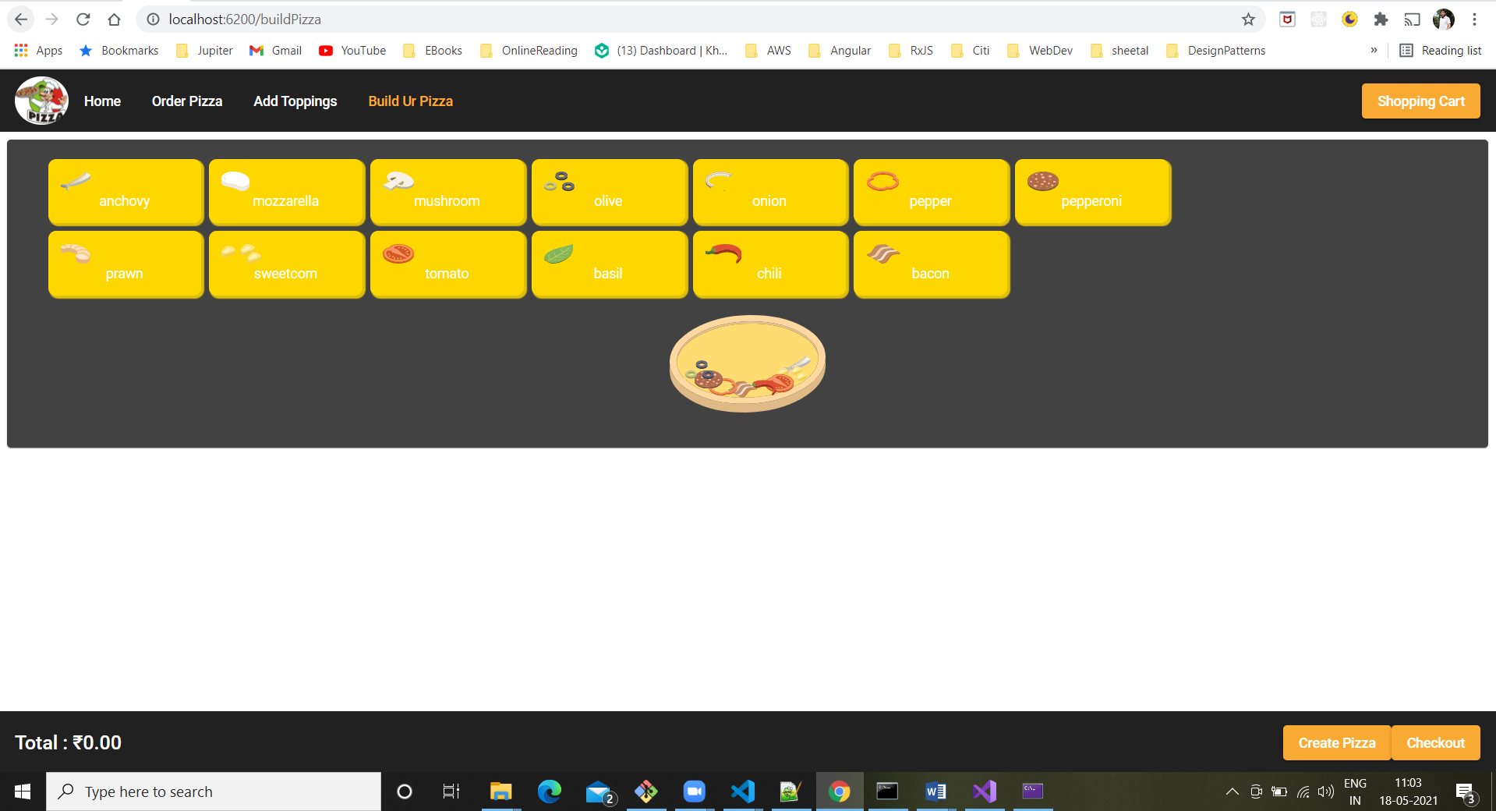

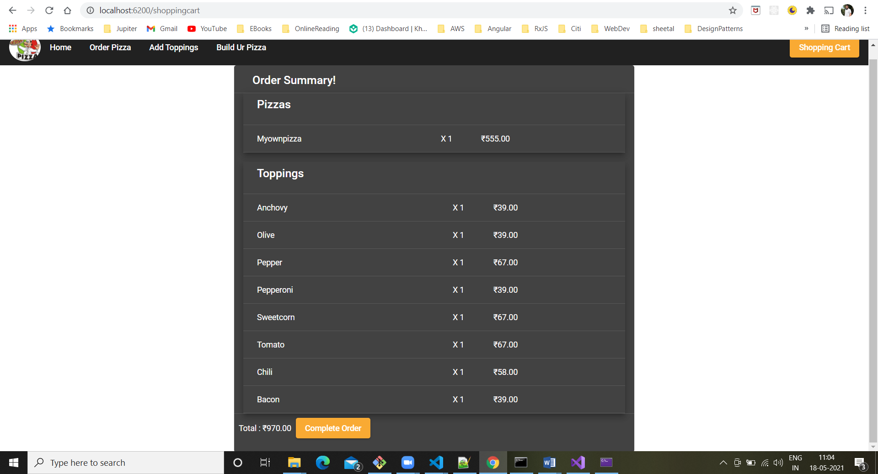

**Online Pizza Ordering System**

The main objectives of this ordering system are:

**Build your own pizza** – This system will help customers in ordering custom pizzas. So the customer will pick exactly the things which they wants in their pizza. This will surely enhance the image of the pizzeria and customer satisfaction will be more.

**Improves Efficiency**- This system will make things easier for staff as whole ordering process is done by the customer only.

These were the objectives of the online pizza ordering System. Let us now get into the details of the working of this ordering system.

**How this system works**

Let us now understand the working of this system.

Whenever a customer visits the webpage of the pizzeria, the menu will be visible to the customer with the pizzas and other non-pizza products on offer. All the ingredients will be shown at their prices.

**Menu**

The system will provide customers a menu in which all the pizzas and non-pizza items will be shown with their prices. The pizzas on the menu are created by the professional chefs of the pizzeria.

The ingredients in this pizza can be changed according to the customer interests. The customer can select any pizza from the menu or build the custom pizza.

Each pizza will be shown with their image and price. The ingredients used in the making of that pizza can also be seen. Each of these ingredients can be removed or other new ingredients can be added in the order.

After each selection or de-selection, the grand total of the order will be updated.

**Build Your Pizza**

One of the most amazing features of online pizza ordering system is that you can build your pizzas from the scratch. This system provides the options to create your custom pizzas with everything of your choice.

Let me tell you more about making custom pizzas.

·         The customer will get an option to select pizza’s crust size which can be small, medium or large.

·         Then the customer has to choose the sauce to be used on his pizza crust. These can marinara, cheese, ranch, and others.

·         Then the system asks the customer whether to add cheese or not. They also have an option to select for extra cheese.

·         At last the system shows the customers different types of toppings.

One important point to be noticed here is after each step, the updated price of your custom-built pizza is shown to the customers. Each item’s price is also reflected below its image.

After the customer has finished selecting the items to be ordered, the order is saved, and order id is generated for the customer.

**Your solution must consist of**

   1. REST base API which will help UI in retrieving the pizza ingredients and its cost to build the pizza, and storing information provided by end user about the pizza. You can use file system to store the information.

   2. Web site using which user will build their own pizza and save it as an order.

Solution will be evaluated on basis of design patterns used, code structure, code quality, and presence of test cases. You can refer any online pizza website for the name of ingredients and prices.